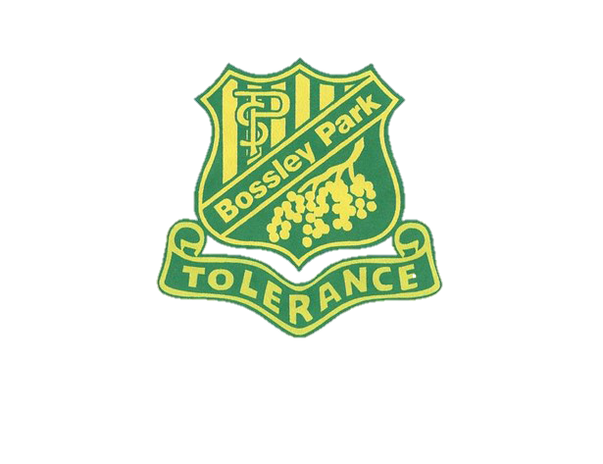
Save the Date

P & C upcoming events in Term 2 2019

Our next P & C meeting is on Monday 20 May 2019 at 7pm in the staff room. All are welcome to attend.

The Mother’s Day Stall will be held at school on Wednesday 8 May 2019. The teachers will bring each class to the studio so that all students have the opportunity to purchase a gift for Mum or Grandma.

We will be holding a BBQ & Cake Stall on Federal Election Day, Saturday 18 May 2019 outside the school hall. Anyone wishing to volunteer for BBQ duty is asked to leave their contact details at the front office or canteen. Alternatively, if you would like to donate baked goods, they can be left at the canteen on Friday 17 May from 2.30pm.

Donuts are a favourite treat for most families and to celebrate a great Term 2 we will be holding a Krispy Kreme Donut drive in Week 10. A note will go home in Week 5 with all the details.

Mr Rodas dedicates his time to maintain the schools’ vegetable garden with the support of the student Gardening Club. He is seeking parent or grandparent volunteers that would like to help out with some garden maintenance once a fortnight. If you have a passion for gardening and are able to assist, please leave your contact details at the office. Any offers of support would be greatly appreciated.

On Wednesday afternoons, starting in Week 2, the ‘Clean & Green Crew’ will be meeting in the flagpole playground after the school bell. This is a wonderful opportunity for you to spend time with your child caring for our school environment.

Further details will be forwarded closer to the date of the event. Looking forward to seeing you there!

Please scan QR code for Arabic translation:
رجاء تفحصوا ال كيو ار كود لتستمعوا الى الترجمة باللغة العربية

Jill Fitzjohn
P & C President
1.5.19

