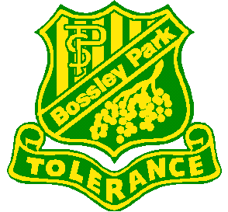
BOSSLEY PARK PUBLIC SCHOOL
ONLINE HOMEWORK SESSION 2019
Dear Parents/Caregivers, 2 May 2019
Do you need help to support your child with Reading Eggs /Eggspress and Mathletics homework?
If so, then you are invited to attend an online homework information session.
When: Tuesday 7 May 2019 at 9.00am
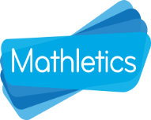
Where: School Library

If you wish to attend, please return the slip below to the office by Monday 6 May 2019.
Thank you for your cooperation and support regarding your child’s education.
Please scan QR code for Arabic translation: رجاء تفحصوا ال كيو ار كود لتستمعوا الى الترجمة باللغة العربية

F. Nobilo T. Betts
Assistant Principal Principal
_______________________________________________________________________________________
ONLINE HOMEWORK WORKSHOP REPLY SLIP
I will be attending the Homework Workshop on Tuesday 7 May 2019 in the School Library.
Name: __________________________ Child’s name and class: _________________________________

BOSSLEY PARK PUBLIC SCHOOL
ONLINE HOMEWORK SESSION 2019
Dear Parents/Caregivers, 2 May 2019
Do you need help to support your child with Reading Eggs /Eggspress and Mathletics homework?
If so, then you are invited to attend an online homework information session.
When: Tuesday 7 May 2019 at 9.00am
Where: School Library

If you wish to attend, please return the slip below to the office by Monday 6 May 2019.
Thank you for your cooperation and support regarding your child’s education.
Please scan QR code for Arabic translation: رجاء تفحصوا ال كيو ار كود لتستمعوا الى الترجمة باللغة العربية

F. Nobilo T. Betts
Assistant Principal Principal
_______________________________________________________________________________________
ONLINE HOMEWORK WORKSHOP REPLY SLIP
I will be attending the Homework Workshop on Tuesday 7 May 2019 in the School Library.
Name: __________________________ Child’s name and class: _________________________________

