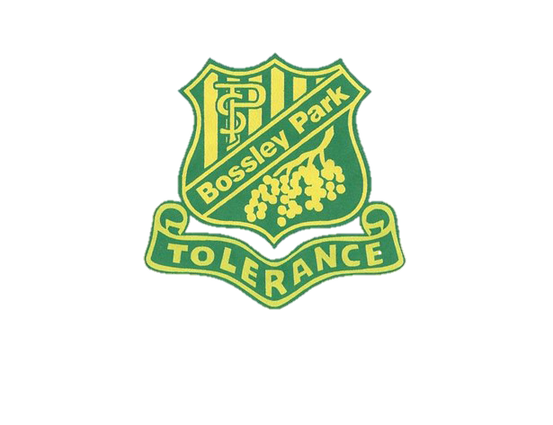
Mother’s Day Stall

The P & C will be holding a Mother’s Day Stall on Wednesday 8 May 2019 in the studio.
Gifts are priced at $3, $4, $5, $6, $7, $8 & $10.
Mother’s Day cards will be on sale for $1.

Class teachers will take the children to the studio during class time to purchase as many gifts as they like. There are no second hand or used items sold at the Mother’s Day Stall. All gifts are new and purchased by the P & C.

We need volunteers to help set up the stall on Tuesday 7 May 2019 from 2pm. If you can help, please meet me at the canteen.

We also need helpers to sell the gifts at the stall on Wednesday 8 May 2019. If you can help, please meet in the studio from 9am.

Please scan QR code for Arabic translation: رجاء تفحصوا ال كيو ار كود لتستمعوا الى الترجمة باللغة العربية
Thank you for your support.

Jill Fitzjohn
P & C President
1.5.19

Mother’s Day Stall

The P & C will be holding a Mother’s Day Stall on Wednesday 8 May 2019 in the studio.
Gifts are priced at $3, $4, $5, $6, $7, $8 & $10.
Mother’s Day cards will be on sale for $1.

Class teachers will take the children to the studio during class time to purchase as many gifts as they like. There are no second hand or used items sold at the Mother’s Day Stall. All gifts are new and purchased by the P & C.

We need volunteers to help set up the stall on Tuesday 7 May 2019 from 2pm. If you can help, please meet me at the canteen.

We also need helpers to sell the gifts at the stall on Wednesday 8 May 2019. If you can help, please meet in the studio from 9am.

Please scan QR code for Arabic translation: رجاء تفحصوا ال كيو ار كود لتستمعوا الى الترجمة باللغة العربية

Thank you for your support.

Jill Fitzjohn
P & C President
1.5.19

