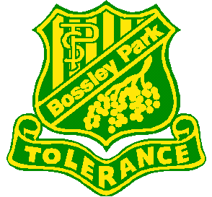
BOSSLEY PARK PUBLIC SCHOOL
Culture Club Aboriginal Dance Lessons
2 May 2019
Dear Parents / Caregivers,
Your child has been selected to participate in Aboriginal dance lessons facilitated by the Fairfield Local Aboriginal Education Consultative Group (FLAECG). There will be four dance lessons led by a trained dance teacher to teach students a dance routine at Guildford Public School. Students will then perform with other FLAECG schools during NAIDOC Weeks celebrations in Term 3. Details about this event will be sent home at a later date.

When: Tuesday 7 May (Term 2 Week 2)
Tuesday 12 May (Term 2 Week 3)
Tuesday 21 May (Term 2 Week 4)
Tuesday 28 May (Term 2 Week 5)
Where: Guildford Public School.
Transport: Travel to and from venue will be by teacher car.
Time: Depart at 11:30am and return to school by 2:30pm.
Cost: Free.
What to bring: Students need to wear full school uniform including a hat and will need to bring along their lunch and drink/s.

Miss Vuong Mrs Betts
Organising Teacher Principal

……………………………………………………………………………………………………………………………………………………………………………
BOSSLEY PARK PUBLIC SCHOOL
Culture Club Aboriginal Dance Lessons
I give permission for my child _______________________________ of class __________ to attend Aboriginal dance lessons at Guildford Public School on Tuesday 7, 12, 21 and 28 May 2019. I understand travel to and from the venue will be by teacher car.

Please indicate any medical condition/s that we need to be aware of (e.g. asthma, allergies etc.).
_____________________________________________________________________________________________

_____________________________________________________________________________________________

Signed: _____________________ Date: __________________

