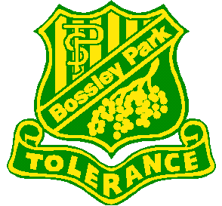
BOSSLEY PARK PUBLIC SCHOOL
BOOK WEEK 2018
Dear Parents / Caregivers,
Term 3 and Book Week is a time when we have the opportunity to focus on books being judged in the Children’s Book Council of Australia competition.
The theme for 2018 is ‘Find Your Treasure’.
As part of the celebration Perform Educational Musicals will visit our school and present a performance on Thursday 16th August. There will be two performances – one for K-2 at 9.40 am and the one for 3-6 at 11.40 am.
All students are encouraged to attend to enjoy this experience which incorporates acting and music with themes from literature.
Please sign and return the permission slip with $7 by Thursday 9th August
Please note: Money is accepted at the Office on Monday, Tuesday and Thursday from 8.30-9.30.
Please complete the permission slip below with the correct money in the envelope provided and post it in the ‘Frog’ letter box by Thursday 9th August OR make a payment online by accessing the school website or Skoolbag app and selecting $ in the Payment option, click Other and enter
‘Book Week Performance’. Write the Receipt Number on the slip below and return it to the office by Thursday 9th August.
Please scan QR code for Arabic translation: رجاء تفحصوا ال كيو ار كود لتستمعوا الى الترجمة باللغة العربية
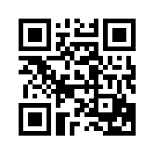

Mrs Turner Mrs Romeiro
Relieving Teacher Librarian Relieving Assistant Principal
___________________________________________________________________________

I give permission for my child ________________________________________
of class _________ to attend the performance of Treasure Hunt on Thursday 16 August. I have included $7.

Signed: ________________________________________ Date: ____________
Online Receipt Number: ____________________________

